(Blue font words are instructions and should not appear in your report.)

Poem report
Poem 99 — Notes
Your name: LASTNAME, classname
Session in which the poem is presented: here

The poem, the poem as 単語, the collection info, and the author info can be pasted in from the web site (might need some proper formatting after the paste). The “details” about the author, however, can and should be expanded by you. As the term progresses, I will be posted fewer of these details perhaps. You might need to just do the work on your own.
99 君や来むわれや行かむのいさよひにまきの板戸もささず寝にけり
きみ | や | く | む | われ | や | ゆか | む | の | いさよひ | に | まき | の | いた | ど | も | ささ | ず | ね | に | けり
Collection: KKS 0690 • 恋 (Book IV) you can add comments here if you think it is useful such as “part of a series of poems on …” or “just after a poem about …”

If you add notes about the poem’s location, you will need to look at the full collection in something like 岩波‘s or 小学館’s 全集 or such.
Author: よみびとしらず (Anonymous) details

Your definition sources are likely to be hardcopy 古語辞典. So expect to go to the library. All the mid-sized 古語辞典 are excellent. You do not need to use larger versions and you don’t need to worry about which publisher or how old the version is. Newer versions tend to include 現代語訳 which is helpful, more illustrations, and some color-coding. (There is next to nothing online in the way of useful 古語辞典. Avoid them and don’t use them as sources below. You can purchase 全訳古語辞典 by 旺文社 for around $23 for laptops, iPads and iPhones. It is an excellent dictionary although it still doesn’t quite beat out a hardcopy in terms of information.) Details can be read via the sidebar tab “Access options for classical dictionaries”
Vocabulary If this is a poem for which you have also be assigned the vocabulary, note that here. If it is not, then make a vocabulary report in the same way (but don’t add to GoogleDocs) and submit it and not that here.
NOTES

This is where you can shine in your report. (The example has only one note and no general comments. Your report should do more than this.) You should write your opinion, commentary and so on of the poem. Feel free to relate the poem to other poems and explore web-based analysis of specific poems (if you type in the poem or part of it you should get some hits, since I’ve used mostly famous poems). If you have drawn from ANY of these other sources even slightly, you must list them. (If you do not, you will receive an “F” for this entire grade category, no second chances, even if you have submitted previously and received a grade. You will not be allowed to submit any more reports.)
Images, if any:
I want the URL for both the web site and the image so I can return to the original. I will probably do so to evaluate your notes. Just ANY image/sound is definitely not welcome. It needs to contribute rather specifically to the poem in some way.

Your image sources are likely to be web-based but not necessarily. The EA library has scanners.
When you include an image embed it here if you can but in all cases submit separately the properly titled image with this report.

Don’t forget that sound files might be useful in your case.

Also expect to be the “expert” in class for this poem. Your grade is based both on your written submission and your managing of the poem in class.
Note 1.
Maki no itado (真木の板戸、まきのいたど). I found a web site that gave a modern impression of the poem. I think it does a good job of catching the sense of loneliness and puts focus on the door, even if the door itself doesn’t look like a 真木の板戸:
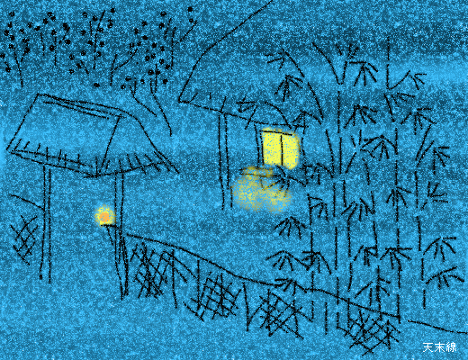
Web site URL: http://blogs.yahoo.co.jp/tenmatsu1000/4284504.html
Image URL: http://img5.blogs.yahoo.co.jp/ybi/1/47/f8/tenmatsu1000/folder/304199/img_304199_4284504_0?1161899139
And this gives a sense of a 板戸 although I can’t decide if the poem is referring to a gate like this or to the actual door to the dwelling. Since the poem mentions a possible visit, it can’t really be out in the mountains like a hut so it is possible this is more like a front gate (aristocrat’s place) than a hut.
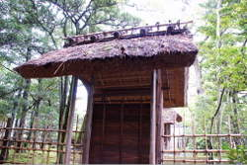
Web site URL (a long blog, scroll down a lot): http://sand-age.cocolog-nifty.com/blog/2009/08/index.html
Image URL: http://sand-age.cocolog-nifty.com/blog/images/2009/08/01/conv0045.jpg

Below is an example of what a submission might look like, once all the blue font is removed. Also, when uploading to GoogleDocs, there is no need to keep the Vocabulary line(s).

Poem 99 — Notes
Your name: WALLACE, John
Session in which the poem is presented: 7 (not true! This is just an example ….)
99 君や来むわれや行かむのいさよひにまきの板戸もささず寝にけり
きみ | や | く | む | われ | や | ゆか | む | の | いさよひ | に | まき | の | いた | ど | も | ささ | ず | ね | に | けり
Collection: KKS 0690 • 恋 (Book IV) blah-blah
Author: よみびとしらず (Anonymous) blah-blah
Vocabulary (see XXX document submitted at the same time)
NOTES
Note 1.
Maki no itado (真木の板戸、まきのいたど). I found a web site that gave a modern impression of the poem. I think it does a good job of catching the sense of loneliness and puts focus on the door, even if the door itself doesn’t look like a 真木の板戸:
Web site URL: http://blogs.yahoo.co.jp/tenmatsu1000/4284504.html
Image URL: http://img5.blogs.yahoo.co.jp/ybi/1/47/f8/tenmatsu1000/folder/304199/img_304199_4284504_0?1161899139
And this gives a sense of a 板戸 although I can’t decide if the poem is referring to a gate like this or to the actual door to the dwelling. Since the poem mentions a possible visit, it can’t really be out in the mountains like a hut so it is possible this is more like a front gate (aristocrat’s place) than a hut.
Web site URL (a long blog, scroll down a lot): http://sand-age.cocolog-nifty.com/blog/2009/08/index.html
Image URL: http://sand-age.cocolog-nifty.com/blog/images/2009/08/01/conv0045.jpg

